**PRJ666 – MemBot Installation Manual**

**Option 1: Run app in web browser on PC or MAC**

The MemBot app is already uploaded and hosted on appetize.io

Simply open this link in a browser: <https://appetize.io/app/3bb6j4jeaf2rkmjhugty20ne30>

You will be taken to a virtualized / emulated version of the app. At the bottom of the screen, click the “Pixel 4” button:

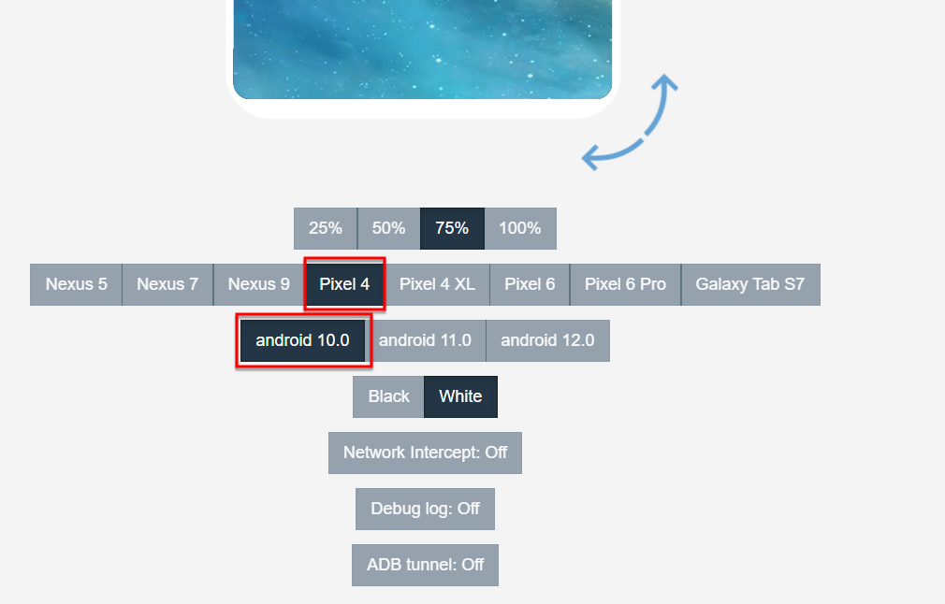

Make sure the “android 10.0” button is also selected.

Then click the “Tap to play” button on the virtual device:

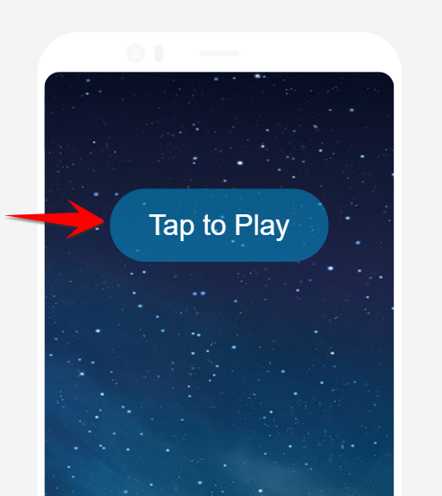

This will install the app and run it.

**Option 2: Download APK file from GitHub repo using an Android device**

Using an android device, open a web browser and download the APK file from the GitHub repo:

<https://github.com/kanika-06/Group_01/blob/master/app-debug.apk>

This will download the file to your device. After downloading, open the file and select “install”. Follow the instructions to complete installation and then click the app icon on your home screen.